Visitor Management System

Description:

Visitor Management system is a portal by which Employee can request for upcoming Visitors. Receptionist can overall manage the entry and exit of visitors. By validating their Identity. With one request there can be multiple visitors which may opt to exit on same time or different time.

Usage Scenario:

* Visitor Management can be integrated into various applications, so that they can easily manage visitors without hassle.

Pre-requisites:

* Mendix Studio Pro Version 9.24.5

Required Marketplace Modules:

* Mx Model Reflection
* Excel Importer
* Excel Exporter
* User Excel Management
* Encryption
* Email Connector

Steps to Configure:

1. First Download the Module. Then we should login as an Admin.
2. After Downloading the Required Modules. The Admin has to configure a email account with email connector module. This Email Account is Used to Send Emails to the Adminstrators of the Application.

Application -> Application Configuration -> Email

1. The Admin Should Configure the Purpose of Visit and Id Types Values by going into the Master Data. The Values that are entered here will be visible for the Front Desk Executive while creating a Request.

Application -> Master Data -> ID Types

Application -> Master Data -> Purpose

1. First Refresh All the Modules by going into MxReflection in Application Configuration.

Application -> Application Configuration -> MxReflection

1. The Admin Should Configure the Export by going into Application Configuration. Then you need to add a template with name “visitorExport” and configure the visitor entity attributes which need to shown in the downloaded Document.

Application -> Application Configuration -> Export

1. The Admin Should Configure the Import Template or They can Import the Template by going into Application Configuration.

Application -> Application Configuration -> Import

Steps to Implement:

1. The Module Contains 3 User Roles: Admin, Employee and Front Desk Executive.
2. The Admin has Access to all the pages where as the Front Desk Executive has only access to Request and Visitors Page.
3. The Admin has to configure a email account with email connector module. This Email Account is Used to Send Emails to the Adminstrators of the Application.
4. The Admin also need to add 2 templates in the email configured. One is for Admin Sender Template in the Constants folder of app where the name of the monthly visitor report configured in email connector should be added. Same with the Request Sender Template which should contain the name of the template which is sent to the person whose mail id is given while raising Request.
5. The Admin Should Configure the Purpose of Visit and Id Types Values by going into the Master Data. The Values that are entered here will be visible for the Front Desk Executive while creating a Request.
6. Admin Can Manage the users by using the User Management.
7. The Send Mail in the Visitors Overview Page Sends the Mail with the Template that is added in Admin Sender Template to only administrators present the application.
8. The Download button downloads the list of Visitors based on the visitor template configured in the Export.
9. Admin can import the old visitors data based on the template present in the import section of Application Configuration.

Features:

1. Employee can provide information that visitors are expected.​
2. Add New visitors.​
3. Manage all visitors of the application.​
4. Today’s visitor info can be re-edit if filled wrong.​
5. Send email to the requestor mail id with the list of visitors.
6. Revisiting visitor details auto fill based on contact number.​
7. Clicking entry picture of visitor and his identity.​
8. Visitor Photo and document can be uploaded from files as well ​
9. A request can have multiple visitors.​
10. Exit all visitor at once.​
11. Exit visitor separately (Marking exit comments).​
12. Visitor reports to admins over email.
13. Overview visitor reports can be exported. ​
14. Old visitor data can also be imported.​
15. Brand logo and theme can be customized.​
16. Multilanguage support.

Import Configure Screenshots:

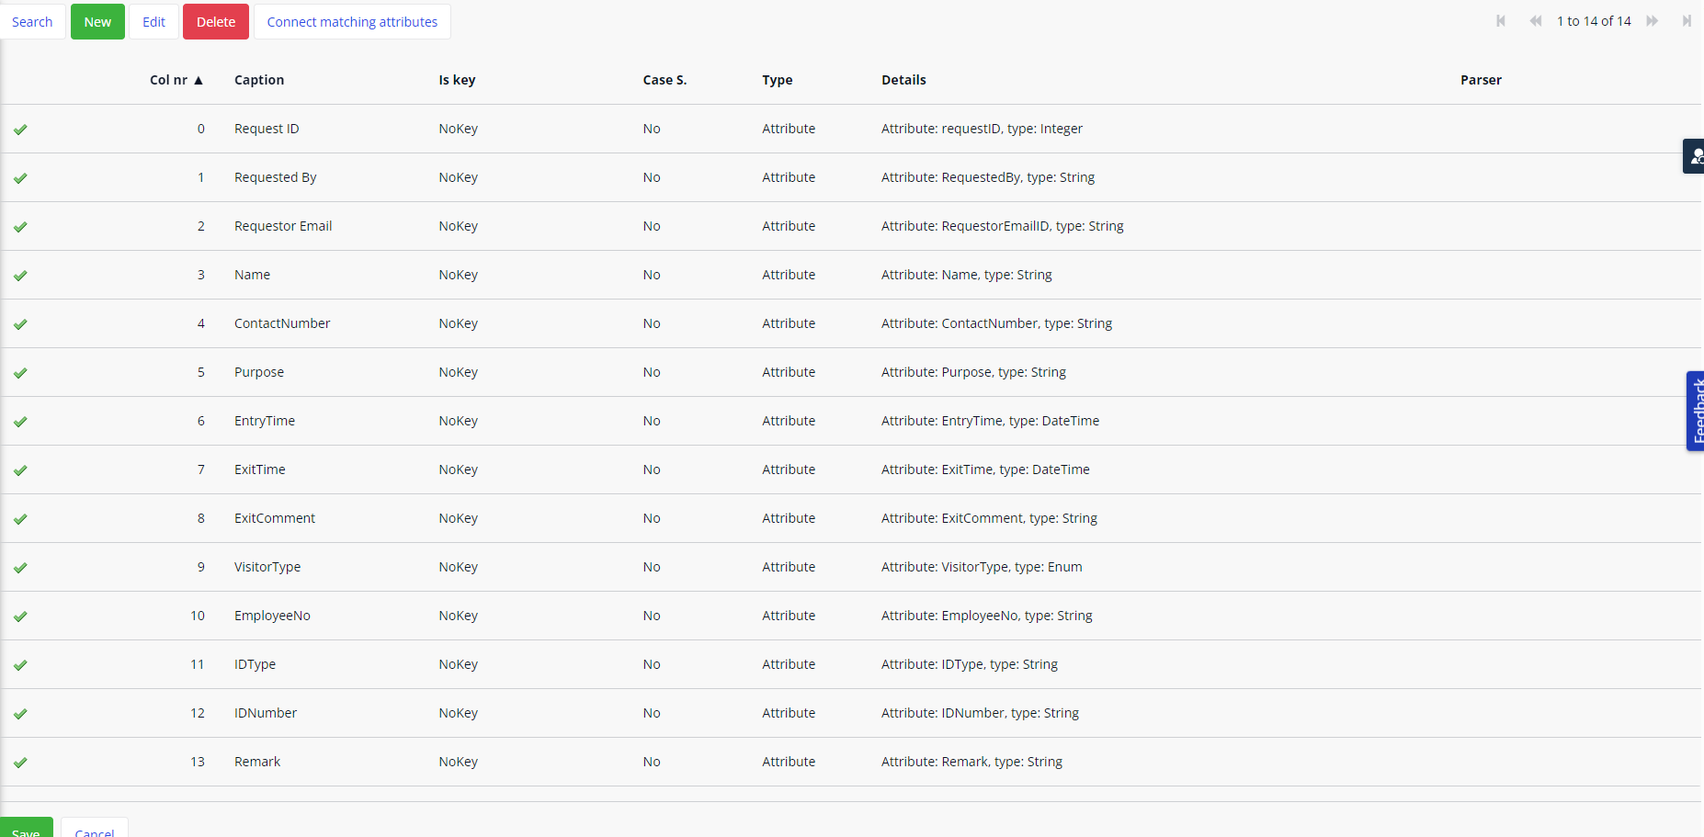

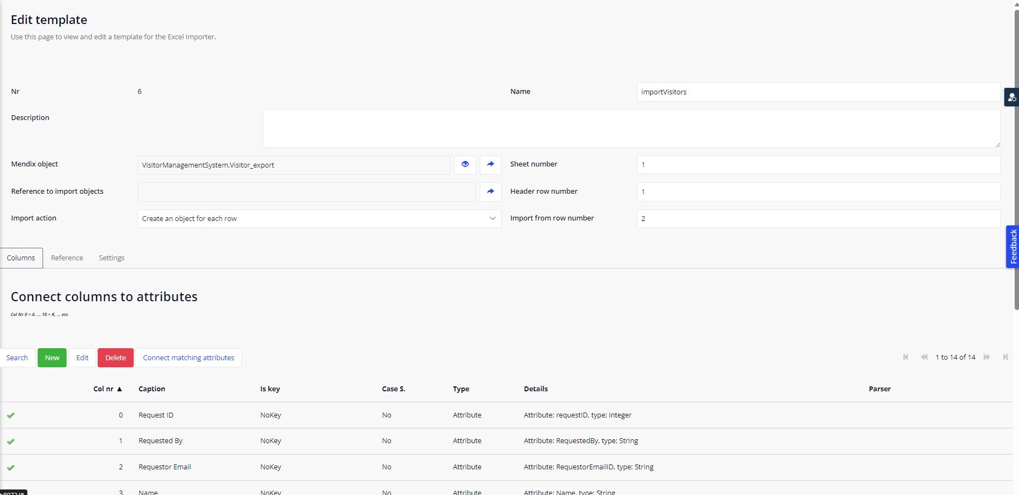

Export Configure Screenshots:

